**Exercise 1: Control Structures**

**Scenario 1:** The bank wants to apply a discount to loan interest rates for customers above 60 years old.

* **Question:** Write a PL/SQL block that loops through all customers, checks their age, and if they are above 60, apply a 1% discount to their current loan interest rates.

SET SERVEROUTPUT ON;

DECLARE

CURSOR customer_cursor IS

SELECT CustomerID, TRUNC((SYSDATE - DOB) / 365.25) AS Age

FROM Customers;

v_customer_id Customers.CustomerID%TYPE;

v_age NUMBER;

v_updated_loans NUMBER := 0;

BEGIN

FOR customer_rec IN customer_cursor LOOP

v_customer_id := customer_rec.CustomerID;

v_age := customer_rec.Age;

IF v_age > 60 THEN

UPDATE Loans

SET InterestRate = InterestRate * 0.99

WHERE CustomerID = v_customer_id;

IF SQL%ROWCOUNT > 0 THEN

v_updated_loans := v_updated_loans + SQL%ROWCOUNT;

DBMS_OUTPUT.PUT_LINE('Updated Loan for Customer ID: ' || v_customer_id || ' with new interest rate.');

END IF;

END IF;

END LOOP;

COMMIT;

END;

/

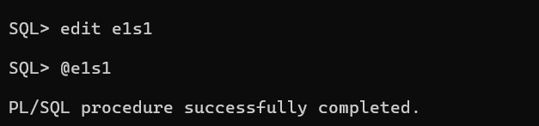

**Scenario 2:** A customer can be promoted to VIP status based on their balance.

* **Question:** Write a PL/SQL block that iterates through all customers and sets a flag IsVIP to TRUE for those with a balance over $10,000.

ALTER TABLE Customers ADD (IsVIP VARCHAR2(3));

SET SERVEROUTPUT ON;

DECLARE

CURSOR customer_cursor IS

SELECT CustomerID, Balance

FROM Customers;

v_customer_id Customers.CustomerID%TYPE;

v_balance Customers.Balance%TYPE;

BEGIN

FOR customer_rec IN customer_cursor LOOP

v_customer_id := customer_rec.CustomerID;

v_balance := customer_rec.Balance;

IF v_balance > 10000 THEN

UPDATE Customers

SET IsVIP = 'YES'

WHERE CustomerID = v_customer_id;

IF SQL%ROWCOUNT > 0 THEN

DBMS_OUTPUT.PUT_LINE('Promoted Customer ID: ' || v_customer_id || ' to VIP status.');

END IF;

END IF;

END LOOP;

COMMIT;

DBMS_OUTPUT.PUT_LINE('VIP promotion process completed.');

END;

/

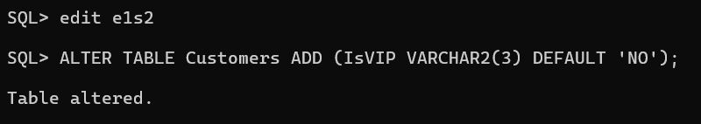

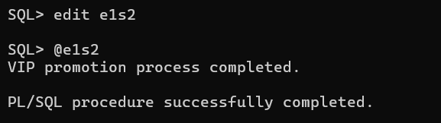

**Scenario 3:** The bank wants to send reminders to customers whose loans are due within the next 30 days.

* **Question:** Write a PL/SQL block that fetches all loans due in the next 30 days and prints a reminder message for each customer.

SET SERVEROUTPUT ON;

DECLARE

CURSOR loan_cursor IS

SELECT l.LoanID, l.CustomerID, c.Name, l.EndDate

FROM Loans l

JOIN Customers c ON l.CustomerID = c.CustomerID

WHERE l.EndDate BETWEEN SYSDATE AND SYSDATE + 30;

v_loan_id Loans.LoanID%TYPE;

v_customer_id Loans.CustomerID%TYPE;

v_customer_name Customers.Name%TYPE;

v_end_date Loans.EndDate%TYPE;

BEGIN

FOR loan_rec IN loan_cursor LOOP

v_loan_id := loan_rec.LoanID;

v_customer_id := loan_rec.CustomerID;

v_customer_name := loan_rec.Name;

v_end_date := loan_rec.EndDate;

DBMS_OUTPUT.PUT_LINE('Reminder: Customer ' || v_customer_name || ' (ID: ' || v_customer_id || ') has a loan (ID: ' || v_loan_id || ') due on ' || v_end_date || '.');

END LOOP;

DBMS_OUTPUT.PUT_LINE('Reminder process completed.');

END;

/

